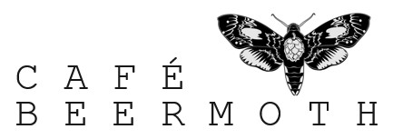
Job Application Form 2018
Please download and consult the relevant job description/ person specification before filling in the job application form below.
Please email this to jobs@beermoth.co.uk and enter the job you are applying for in the subject.
Please make sure that the form is sent as either a PDF or as a Word Document.
Please provide your contact details.
Including name, address, email and mobile phone number.

Which position are you applying for?

Why would you like to work with us?

What relevant work experience have you got?
Please consult relevant job description.
(Maximum of one page)

Employment history
Job title | Location | Duration

How much notice, if currently employed, would you have to provide?

Supporting details
(Maximum of one page)

We will be making a shortlist for interviews as soon as possible.
jobs@beermoth.co.uk
Any questions please use the email address above.

Many thanks.
Jeremy Stull
Director

